DELHI TECHNOLOGICAL UNIVERSITY

OPERATING SYSTEM SUBJECT CODE : MC-202
LAB REPORT
Submitted By:

LOKESH GODARA
(23/MC/82)

Submitted To:
Mrs. Trash Gupta & Mr. Yash


DEPARTMENT OF APPLIED MATHEMATICS
DELHI TECHNOLOGICAL UNIVERSITY
(FORMELY DELHI COLLEGE OF ENGINEERING)
BAWANA ROAD , DELHI – 110042

INDEX

S.No. | Experiments | Date | Remarks
1. | Write a C program to copy the contents of one file to another file using system calls like read(), write(), open() and close()
2. | Write a program to create a child process using _{fork()}. Print the process ID of child and the parent process. Also explain the behavior of fork in parent and child process..
3. | Write a program that creates a new child process using _{fork()}. The child process should be assigned to find the length of your name using the _{execlp()} system call
4. | Write a program that creates another process. The child process should print the contents of any text on the screen using the _{cat} command. The parent process should exit only after the child process has completed its execution..
5. | Write a program that creates another process. The child process should print the contents of any text on the screen using the _{cat} command. The parent process should exit only after the child process has completed its execution.
6. | Write a program to implement the SSTF and LOOK Disk Scheduling Algorithms.  Print the seek time for each algorithm. You may consider your own input queue for the requests (cylinder numbers).
7. | Write a menu-driven program to implement First Come First Serve and Shortest Time First Algorithm (Non-Preemptive) scheduling algorithm.  Input - Sequence of Processes with their arrival time and burst time. Output - Sequence of processes executing, Average Waiting time and Average Turnaround time.
8. | Write a menu-driven program to implement Round Robin Algorithm.  Input - Sequence of Processes with their arrival time and burst time and Maximum Time Quantum. Output - Sequence of processes executing, Average Waiting time and Average Turnaround time.
9. | Write a menu-driven program to implement the Shortest Remaining  Time First and Preemptive Priority-based Scheduling Algorithms. Input -  Sequence of Processes with their arrival time and burst time. Output - Sequence of processes executing, Average waiting time and Average Turnaround time.
10. | Write a program to implement Banker's Algorithm. The program should either print the safe sequence of execution of given processes (if any exists) or print "There is a deadlock in the system.
11. | Write a program to implement FIFO and Least Recently Used algorithm for page replacement. Input - Reference String and Number of frames.  Output - Number of page faults for each LRU and FIFO.

Experiment1

Write a C program to copy the contents of one file to another file using system calls like _{read()}, _{write()}, _{open()} and close()

Code:
#include <stdio.h>
#include <stdlib.h>
#include <fcntl.h>
#include<unistd.h>

int main() { char ch;
intfd,td;
ssize_tnread;

char source_file[] = "input.txt"; chartarget_file[]="output.txt";

fd=open(source_file,O_RDONLY); if
(fd < 0) { perror("Erroropeningsourcefile");
exit(EXIT_FAILURE);
}
td=open(target_file,O_WRONLY|O_CREAT|O_TRUNC,0644); if (td
< 0) { perror("Erroropeningtargetfile"); close(fd);
exit(EXIT_FAILURE);
}
while((nread=read(fd,&ch,1))>0){ if
(write(td, &ch, 1) != 1) { perror("Errorwritingtotargetfile"); close(fd); close(td);
exit(EXIT_FAILURE);
}
}
if(nread<0){ perror("Errorcopyingcontentfromsourcefile");
}else{ printf("Filecopiedsuccessfully.\n");
}
close(fd); close(td);

return0;
}

Output:

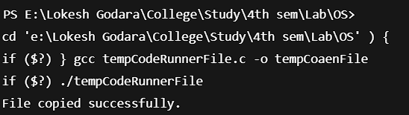

Experiment2

Write a program that creates a new child process using _{fork()}. The child process should be assigned to find the length of your name using the _{execlp()} system call.
Code:

#include <stdio.h>
#include<unistd.h>

int main() { pid_t pid; pid=fork(); if(pid<0){
//erroroccurred perror("fork"); return 1;
}elseif(pid==0){ // child process printf("ChildProcess:\n"); printf("Child PID: %d\n", getpid()); printf("ParentPID:%d\n",getppid());
}else{
// inside parent process printf("Parent Process:\n"); printf("ParentPID:%d\n",getpid());
printf("Child PID: %d\n", pid);
}
return0;
}
Output

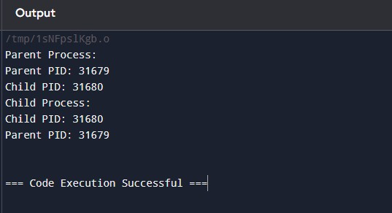

Experiment3
Aim:
Write a program that creates a new child process using _{fork()}. The child process should be assigned to find the length of your name using the _{execlp()} system call..
Code:

#include <stdio.h>
#include <stdlib.h>
#include <unistd.h>
#include<sys/wait.h>

intmain(){ pid_tpid=fork();

if (pid < 0) { perror("Forkfailed"); exit(1);
}
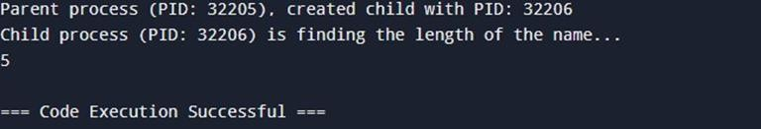
if(pid==0){ printf("Childprocess(PID:%d)isfindingthelengthofthename...\n",getpid());

execlp("/bin/sh","sh","-c","printfMyank'|wc-c",(char*)NULL); perror("execlp failed"); // Error if execlp fails exit(1);
}
else{ printf("Parentprocess(PID:%d),createdchildwithPID:%d\n",getpid(),pid); wait(NULL); // Wait for the child process to complete
}

return0;
}
Output:

Experiment4

Write a program that creates another process. The child process should print the contents of any text on the screen using the _{cat} command. The parent process should exit only after the child process has completed its execution.
Code:
#include <stdio.h>
#include <stdlib.h>
#include <unistd.h> #include<sys/wait.h> int main() { pid_tpid=fork(); if (pid < 0) { perror("Forkfailed"); return 1;
}elseif(pid==0){ execlp("cat","cat","code4_test.txt",(char*)NULL); perror("execlp failed"); exit(1);
}else{ int status; printf("\n"); waitpid(pid,&status,0); if(WIFEXITED(status)){ printf("\nChildprocessexitedwithstatus%d\n",WEXITSTATUS(status));
}
printf("Parentprocessexiting.\n");
}
return0;
}
Output:

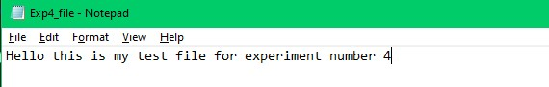

Experiment5

Write a program to implement the FCFS and Elevator Algorithm for Disk Scheduling. Print the Seek time for each algorithm. You may consider your own input queue for the requests (cylinder no.).

Code:
#include<bits/stdc++.h> using namespace std; voidFCFS(constvector<int>&requests,intinitial_head){ int seek_time = 0; int current_position = initial_head; cout<<"FCFSDiskScheduling\n";
cout<<"InitialHeadPosition:"<<initial_head<<"\n";

for(intrequest:requests){ intdiff=abs(request-current_position); seek_time += diff; current_position=request;
cout<<"ServedRequest:"<<request<<",SeekTime:"<<diff<<"\n";
}
cout<<"TotalSeekTime:"<<seek_time<<"\n\n";
}

voidSCAN(vector<int>requests,intinitial_head,intdisk_size){ int seek_time = 0;
intcurrent_position=initial_head;
intdirection=1;//1meansmovingtowardshighercylinders

sort(requests.begin(),requests.end());

cout<<"SCANDiskScheduling\n";
cout<<"InitialHeadPosition:"<<initial_head<<"\n";

//Findthepositionoftheheadinthesortedlist
autoit=lower_bound(requests.begin(),requests.end(),initial_head); int index = it - requests.begin();
//Movetotheleftsideoftheinitialhead if
(direction) { for(inti=index-1;i>=0;i--){ intdiff=abs(requests[i]-current_position); seek_time += diff; current_position=requests[i];
cout<<"ServedRequest:"<<requests[i]<<",SeekTime:"<<diff<<"\n";
}
}
//Movetotherightsideoftheinitialhead for(inti=index;i<requests.size(); i++){ intdiff=abs(requests[i]-current_position); seek_time += diff; current_position=requests[i];
cout<<"ServedRequest:"<<requests[i]<<",SeekTime:"<<diff<<"\n";
}

cout<<"TotalSeekTime:"<<seek_time<<"\n\n";

}

intmain(){ vector<int>requests={19,80,24,159,110,213,62,64}; intinitial_head=25;
intdisk_size=400;//Assumethesizeofthedisk is400cylinders

// FCFS Scheduling
FCFS(requests,initial_head);

//SCANScheduling
SCAN(requests,initial_head,disk_size);

return0;
}
Output:
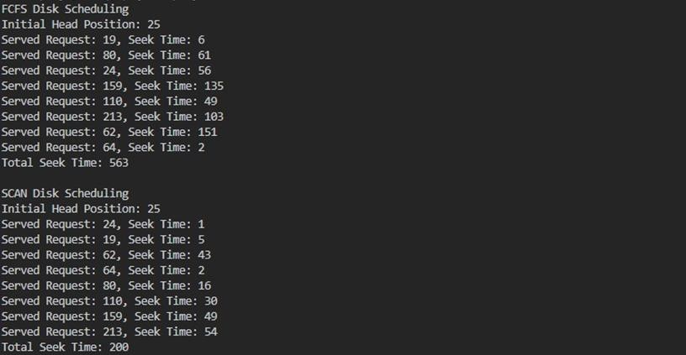

Experiment-6

Aim:
Write a program to implement the SSTF and LOOK Disk Scheduling Algorithms. Print the seek time for each algorithm. You may consider your own input queue for the requests (cylinder no.).
Code:
#include<bits/stdc++.h> using namespace std;
void SSTF(vector<int>& requests, int initial_head) { intseek_time=0,current_position=initial_head; vector<bool> visited(requests.size(), false); cout<<"SSTFDiskScheduling\nInitialHeadPosition:"<<initial_head<<"\n"; for (int
i = 0; i < requests.size(); i++) { int min_dist = 1e6, min_index = -1; for(intj=0;j<requests.size();j++){ if(!visited[j]&&abs(requests[j]-current_position)<min_dist){ min_dist = abs(requests[j] - current_position); min_index=j;
}
}
seek_time += min_dist;current_position=requests[min _index]; visited[min_index] = true;
cout<<"ServedRequest:"<<requests[min_index]<<",SeekTime:"<<min_dist<<"\n";
}
cout<<"TotalSeekTime:"<<seek_time<<"\n\n";
}

voidLOOK(vector<int>&requests,intinitial_head){ intseek_time=0,current_position=initial_head; sort(requests.begin(), requests.end()); cout<<"LOOKDisk Scheduling\nInitialHeadPosition:"<<initial_head<<"\n"; auto
pos = lower_bound(requests.begin(), requests.end(), initial_head); for(autoit=pos;it!=requests.end();++it){ seek_time += abs(*it - current_position);
cout<<"ServedRequest:"<<*it<<", SeekTime:"<<abs(*it-current_position)<<"\n"; current_position = *it;
}
for(autoit=pos-1;it>=requests.begin();--it){ seek_time+=abs(*it-current_position);
cout<<"ServedRequest:"<<*it<<", SeekTime:"<<abs(*it-current_position)<<"\n"; current_position = *it;
}
cout<<"TotalSeekTime:"<<seek_time<<"\n\n";
}
intmain(){ vector<int>requests={19,80,24,159,110,213,62,64}; int initial_head = 25;
SSTF(requests,initial_head);
LOOK(requests,initial_head);
return 0;
}
Output:
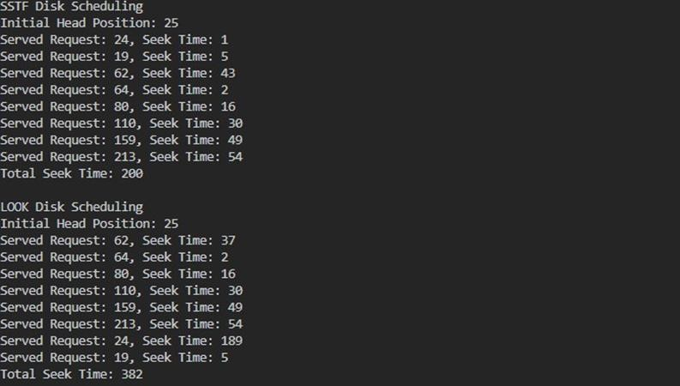

Experiment7

Aim:
Write a menu-driven program to implement First Come First Serve and Shortest Time First Algorithm (NonPreemptive) scheduling algorithm. Input - Sequence of Processes with their arrival time and burst time. Output - Sequence of processes executing, Average Waiting time and Average Turnaround time.
Code:
#include<bits/stdc++.h> using namespace std;
struct Process { intprocess_id,arrival_time,burst_time,waiting_time=0,turnaround_time=0,completion_time=0;
};

voidFCFS(vector<Process>&processes){ int total_waiting_time = 0, total_turnaround_time = 0; processes[0].turnaround_time = processes[0].burst_time; processes[0].completion_time=processes[0].turnaround_time; for
(int i = 1; i < processes.size(); i++) { processes[i].waiting_time=max(0,processes[i-1].completion_time-processes[i].arrival_time); processes[i].turnaround_time = processes[i].waiting_time + processes[i].burst_time; processes[i].completion_time = processes[i].arrival_time + processes[i].turnaround_time; total_waiting_time += processes[i].waiting_time; total_turnaround_time+=processes[i].turnaround_time;
}
cout<<"\nFCFSScheduling\nProcess\tArrivalTime\tBurstTime\tWaitingTime\tTurnaroundTime\n"; for
(auto& p : processes) cout<<p.process_id<<"\t"<<p.arrival_time<<"\t\t"<<p.burst_time<<"\t\t"
<<p.waiting_time<<"\t\t"<<p.turnaround_time<<"\n"; cout<<"AverageWaitingTime:"<<(float)total_waiting_time/processes.size()<<"\n"; cout<<"AverageTurnaroundTime:"<<(float)total_turnaround_time/processes.size()<<"\n";
}
voidSJF(vector<Process>&processes){ inttotal_waiting_time=0,total_turnaround_time=0;
sort(processes.begin(), processes.end(),[](Processa,Processb){returna.burst_time<b.burst_time;}); processes[0].turnaround_time = processes[0].burst_time; processes[0].completion_time=processes[0].turnaround_time; for
(int i = 1; i < processes.size(); i++) { processes[i].waiting_time=max(0,processes[i-1].completion_time-processes[i].arrival_time); processes[i].turnaround_time = processes[i].waiting_time + processes[i].burst_time; processes[i].completion_time = processes[i].arrival_time + processes[i].turnaround_time; total_waiting_time += processes[i].waiting_time; total_turnaround_time+=processes[i].turnaround_time;
}

cout<<"\nSJFScheduling\nProcess\tArrivalTime\tBurstTime\tWaitingTime\tTurnaroundTime\n"; for
(auto& p : processes) cout<<p.process_id<<"\t"<<p.arrival_time<<"\t\t"<<p.burst_time<<"\t\t" <<p.waiting_time<<"\t\t"<<p.turnaround_time<<"\n";
cout<<"AverageWaitingTime:"<<(float)total_waiting_time/processes.size()<<"\n"; cout<<"AverageTurnaroundTime:"<<(float)total_turnaround_time/processes.size()<<"\n";
}

intmain(){ intn, choice; cout<<"Enterthenumberofprocesses:"; cin
>> n;
vector<Process>processes(n);
for (int i = 0; i < n; i++) { processes[i].process_id=i+1;
cout<<"\nEnter arrivaltime andbursttimefor Process"<<i+1<<":"; cin >> processes[i].arrival_time >> processes[i].burst_time;
}

do{ cout<<"\nMenu:\n1.FirstComeFirstServe(FCFS)\n2.ShortestJobFirst(SJF)(Non-Preemptive)\n3.
Exit\nEnteryourchoice:"; cin >> choice;
if (choice == 1) FCFS(processes); elseif(choice==2)SJF(processes);
elseif(choice!=3)cout<<"Invalidchoice.Pleasetryagain.\n";

}while(choice!=3);

return0;
}
Output:
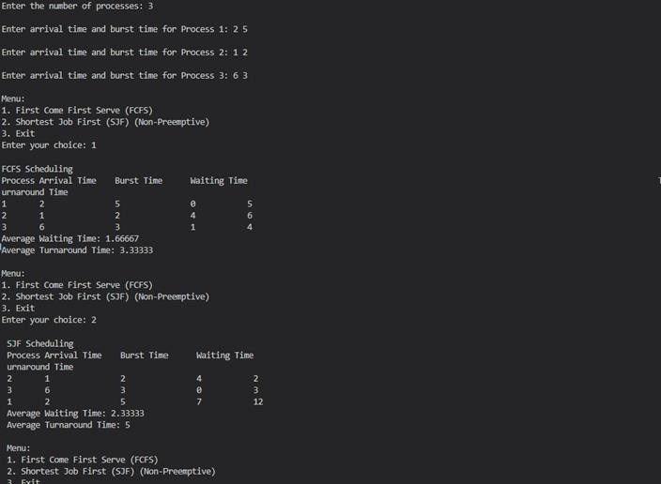

Experiment8
Aim:
Write a menu-driven program to implement Round Robin Algorithm. Input - Sequence of Processes with their arrival time and burst time and Maximum Time Quantum. Output - Sequence of processes executing, Average Waiting time and Average Turnaround time.
Code:
#include<bits/stdc++.h> using namespace std;
structProcess{ intprocess_id,arrival_time,burst_time,remaining_time,waiting_time=0,turnaround_time=0, completion_time = 0;
};

voidroundRobin(vector<Process>&processes,inttime_quantum) { inttime=0,completed=0,total_waiting_time=0,total_turnaround_time=0; for
(auto& p : processes) p.remaining_time = p.burst_time;
while(completed<processes.size()){ bool all_done = true; for(auto&p:processes){ if(p.remaining_time>0){ all_done = false;
if(p.remaining_time>time_quantum){ time += time_quantum;
p.remaining_time -= time_quantum;
}else{ time+= p.remaining_time;
p.waiting_time=time-p.arrival_time-p.burst_time;
p.turnaround_time = p.waiting_time + p.burst_time;
p.completion_time = time;
p.remaining_time=0;
completed++;
}
}
}
if(all_done)break;
}

cout<<"\nRoundRobinScheduling\nTimeQuantum:"<<time_quantum<<"\n"; cout
<<"Process\tArrival Time\tBurst Time\tWaiting Time\tTurnaround Time\n"; for
(auto& p : processes) { cout<<p.process_id<<"\t"<<p.arrival_time<<"\t\t"<<p.burst_time<<"\t\t"
<<p.waiting_time<<"\t\t"<<p.turnaround_time<<"\n"; total_waiting_time += p.waiting_time;total_turnaround_time += p.turnaround_time;
}
cout<<"AverageWaitingTime:"<<(float)total_waiting_time/processes.size()<<"\n"; cout<<"AverageTurnaroundTime:"<<(float)total_turnaround_time/processes.size()<<"\n";
}

intmain(){ intn,time_quantum,choice; cout<<"Enterthenumberofprocesses:"; cin
>> n;
vector<Process>processes(n);
for (int i = 0; i < n; i++) { processes[i].process_id=i+1;
cout<<"\nEnter arrivaltime andbursttimefor Process"<<i+1<<":"; cin >> processes[i].arrival_time >> processes[i].burst_time;
}

cout<<"EnterTimeQuantum:"; cin
>> time_quantum;
do{ cout<<"\nMenu:\n1.RoundRobinScheduling\n2.Exit\nEnteryourchoice:"; cin >> choice;
if(choice==1)roundRobin(processes,time_quantum); elseif(choice!=2)cout<<"Invalidchoice.Pleasetryagain.\n"; }while(choice!=2);

return0;
}

Output:
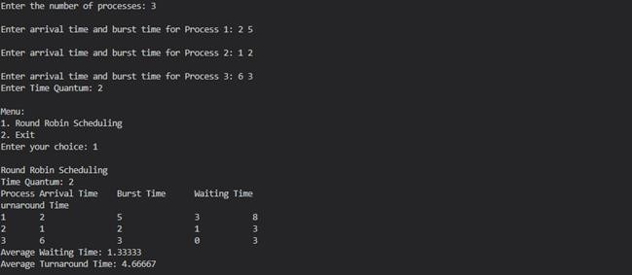

Experiment-9
Aim:
Write a menu-driven program to implement the Shortest remaining time First and Preemptive Priority-basedSchedulingAlgorithms.Input-SequenceofProcesseswiththeirarrivaltimeandburst time. Output- Sequence of processes executing, Average waiting time and Average Turnaround time.

Code:
#include<iostream> #include <vector> usingnamespacestd;
struct Process { intprocess_id,arrival_time,burst_time,remaining_time,waiting_time=0,turnaround_time=0,priority,
completion_time=0;
};

voidSRTF(vector<Process>&processes,intn){ inttime=0,completed=0,total_waiting_time=0,total_turnaround_time=0; for
(auto& p : processes) p.remaining_time = p.burst_time;
while(completed<n){ intmin_remaining_time=9999,min_index=-1; for
(int i = 0; i < n; i++) {
if(processes[i].arrival_time<=time&&processes[i].remaining_time>0&& processes[i].remaining_time < min_remaining_time) { min_remaining_time=processes[i].remaining_time; min_index
= i;
}
}

if (min_index != -1) { processes[min_index].remaining_time--; time++;
if (processes[min_index].remaining_time == 0) { processes[min_index].completion_time = time;
processes[min_index].turnaround_time=processes[min_index].completion_time-
processes[min_index].arrival_time; processes[min_index].waiting_time=processes[min_index].turnaround_time-
processes[min_index].burst_time; completed++;
}
}elsetime++;
}
cout<<"\nSRTFScheduling\n"; for
(auto& p : processes) { cout<<p.process_id<<"\t"<<p.arrival_time <<"\t"<<p.burst_time<<"\t"<< p.waiting_time<<"\t"<< p.turnaround_time <<"\n"; total_waiting_time += p.waiting_time;
total_turnaround_time+=p.turnaround_time;
}

cout<<"AverageWaitingTime:"<<(float)total_waiting_time/n<<"\n"; cout<<"AverageTurnaroundTime:"<<(float)total_turnaround_time/n<<"\n";
}
voidPriorityScheduling(vector<Process>&processes,intn){ inttime=0,completed=0,total_waiting_time=0,total_turnaround_time=0; for
(auto& p : processes) p.remaining_time = p.burst_time;
while(completed<n){ inthighest_priority=-1,highest_priority_index=-1; for
(int i = 0; i < n; i++) {
if(processes[i].arrival_time<=time&&processes[i].remaining_time>0&&(highest_priority==-1|| processes[i].priority < highest_priority)) { highest_priority=processes[i].priority; highest_priority_index = i;
}
}
if (highest_priority_index != -1) { processes[highest_priority_index].remaining_time--; time++;
if (processes[highest_priority_index].remaining_time == 0) { processes[highest_priority_index].completion_time=time; processes[highest_priority_index].turnaround_time =
processes[highest_priority_index].completion_time-processes[highest_priority_index].arrival_time; processes[highest_priority_index].waiting_time =
processes[highest_priority_index].turnaround_time-processes[highest_priority_index].burst_time; completed++;
}
}elsetime++;
}

cout<<"\nPreemptivePriorityScheduling\n";
for (auto& p : processes) { cout<<p.process_id<<"\t"<<p.arrival_time<<"\t"<<p.burst_time<<"\t"<<p.priority<<"\t"<<
p.waiting_time<<"\t"<<p.turnaround_time<<"\n"; total_waiting_time += p.waiting_time;
total_turnaround_time += p.turnaround_time;
}
cout<<"AverageWaitingTime:"<<(float)total_waiting_time/n<<"\n"; cout<<"AverageTurnaroundTime:"<<(float)total_turnaround_time/n<<"\n";
}

intmain(){ intn, choice;
cout<<"Enterthenumberofprocesses:"; cin
>> n;
vector<Process>processes(n); for(inti=0;i< n; i++){ processes[i].process_id=i+ 1;
cout <<"\nEnter arrival time, burst time and priority for Process "<< i + 1 <<": "; cin>>processes[i].arrival_time>>processes[i].burst_time>>processes[i].priority;
}

do{ cout<<"\nMenu:\n1.ShortestRemainingTimeFirst(SRTF)\n2.PreemptivePriorityScheduling\n3.
Exit\nEnteryourchoice:"; cin >> choice;
if(choice==1)SRTF(processes,n);
elseif(choice==2)PriorityScheduling(processes,n); elseif(choice!=3)cout<<"Invalidchoice.Pleasetryagain.\n"; }while(choice!=3);

return0;
}
Output:
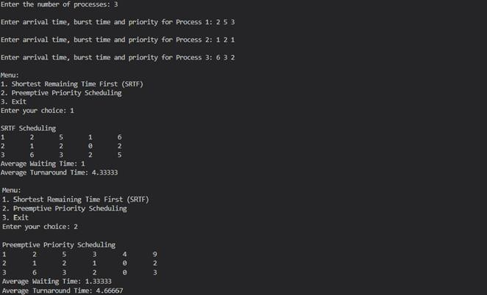

Experiment 10
Aim:
Write a program to implement Banker's Algorithm. The program should either print the safe sequence of execution of given processes (if any exists) or print "There is a deadlock in the system."
Code:
#include<iostream>
#define MAX 10

usingnamespacestd;

boolisSafe(intn,intm, intallocation[][MAX],intmax[][MAX],int available[], intsafeSequence[]){ int work[m], count = 0; boolfinish[n]={false}; for(inti=0; i<m;i++) work[i]=available[i]; while
(count < n) { boolfound=false; for(intp=0;p<n;p++){ if
(!finish[p]) {
bool canExecute = true; for(intr=0;r<m;r++){ if(max[p][r]-allocation[p][r]>work[r]){ canExecute = false; break;
}
}
if(canExecute){ for(intr=0;r<m;r++)work[r]+=allocation[p][r]; safeSequence[count++] = p; finish[p]=true;
found=true;
}
}
}
if(!found)returnfalse;
}
returntrue;
}
intmain(){ intn,m;
cout<<"Enterthenumberofprocessesandresourcetypes:"; cin >> n >> m;
intallocation[n][MAX],max[n][MAX],available[MAX],safeSequence[n]; cout<<"\nEntertheAllocationMatrix:\n"; for
(int i = 0; i < n; i++) for(intj = 0;j <m;j++) cin>>allocation[i][j];
cout<<"\nEntertheMaxMatrix:\n"; for
(int i = 0; i < n; i++) for(intj=0;j<m;j++) cin >> max[i][j];

cout<<"\nEntertheAvailableresources:\n";
for(inti=0;i<m;i++) cin >> available[i];
if (isSafe(n, m, allocation, max, available, safeSequence)) {
cout<<"\nThesystemisinasafestate.\nSafeSequence:"; for
(int i = 0; i < n; i++)
cout<<"P"<<safeSequence[i]<<"";
cout << endl;
}else{ cout<<"\nThereisadeadlockinthesystem.\n";
}

return0;
}
Output:
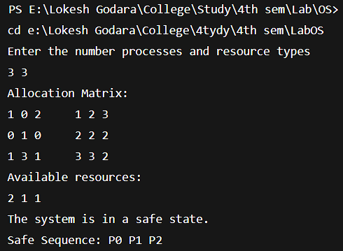

Experiment-11
Write a program to implement FIFO and Least Recently Used algorithm for page replacement. Input - Reference String and Number of frames. Output - Number of page faults for each LRU and FIFO.
Code:
#include <iostream>
#defineMAX_FRAMES10
usingnamespacestd;

intFIFO(intreference[],intn,intframes){ intpage_faults=0,pages[frames],rear=0,front=0; for (int i
= 0; i < frames; i++) pages[i] = -1;
for(inti=0;i<n;i++){ boolis_present=false; for (int j = 0; j < frames; j++) { if(pages[j]==reference[i]){ is_present=true; break;
}
}
if(!is_present){ pages[rear] = reference[i]; rear=(rear+1)%frames;
if(front==rear)front=(front+1)%frames; page_faults++;
}
}
returnpage_faults;
}

intLRU(intreference[],intn,intframes){ intpage_faults=0,pages[frames],last_used[frames]; for
(int i = 0; i < frames; i++) { pages[i]=-1;
last_used[i]=-1;
}

for (int i = 0; i < n; i++) { boolis_present=false; int lru_index = 0;
for (int j = 0; j < frames; j++) { if(pages[j]==reference[i]){ is_present=true; last_used[j] = i;
break;
}
}
if(!is_present){ for(intj= 1;j<frames;j++){ if(last_used[j]<last_used[lru_index])lru_index=j;
}
pages[lru_index]=reference[i]; last_used[lru_index] = i;
page_faults++;
}
}
returnpage_faults;
}

intmain(){ int reference_string[] = {7, 0, 1, 2, 0, 3, 0, 4, 2, 3, 0, 3, 3};intn=sizeof(reference_string)/sizeof(reference_string[0]); int frames;
cout<<"Enterthenumberofframes:"; cin
>> frames; if(frames>n){ cout<<"Framescannotexceedpagesinreferencestring.\n"; return 1;
}

cout<<"FIFOPageFaults:"<<FIFO(reference_string,n,frames)<<'\n'; cout <<"LRU Page Faults: "<< LRU(reference_string, n, frames) <<'\n';
return0;
}
Output:
